**TASK 17**

**10TH EGB**

**NAME:__________**

Activity. ADJECTIVE VOCABULARY

<https://es.liveworksheets.com/tx1632399sv>

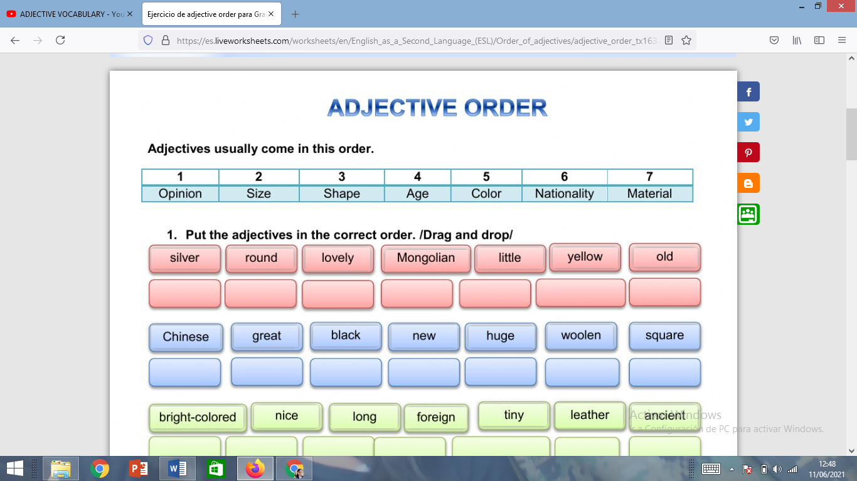



ENGLISH TEACHER:

IMELDA VALDEZ

0979375993