**ACTIVITIES: WEEK 15**

**NAME:______________________**

**LEVEL:_______________________**

**TOPIC: SUFFIXES PREFIXES**

Link : <https://es.liveworksheets.com/bu915355so>

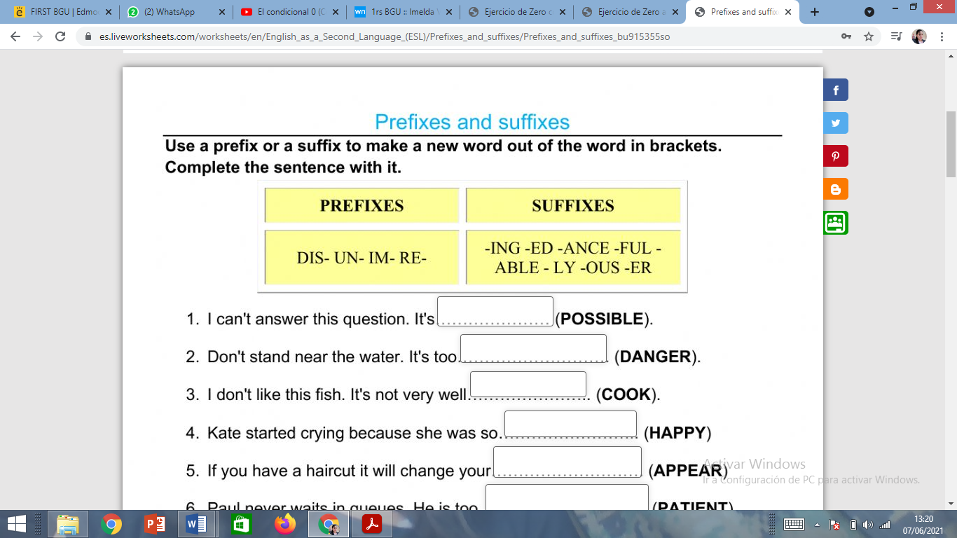

ENGLISH TEACHER:

IMELDA VALDEZ

0979375993