TASK 15 First BGU
NAME:__________
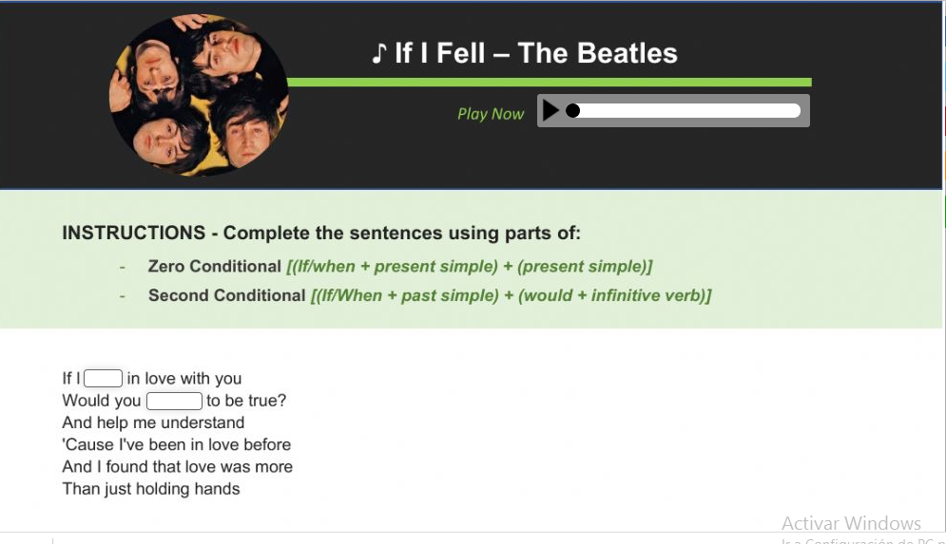

CLAS ACTIVITY: https://es.liveworksheets.com/yb832273hd

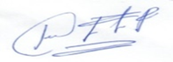
ENGLISH TEACHER:
IMELDA VALDEZ
0979375993

