NAME:______________________
LEVEL: ______________________
ACTIVITY: 16
Class activity : https://es.liveworksheets.com/hl825368xb
Do the activity and take a capture with the grade.

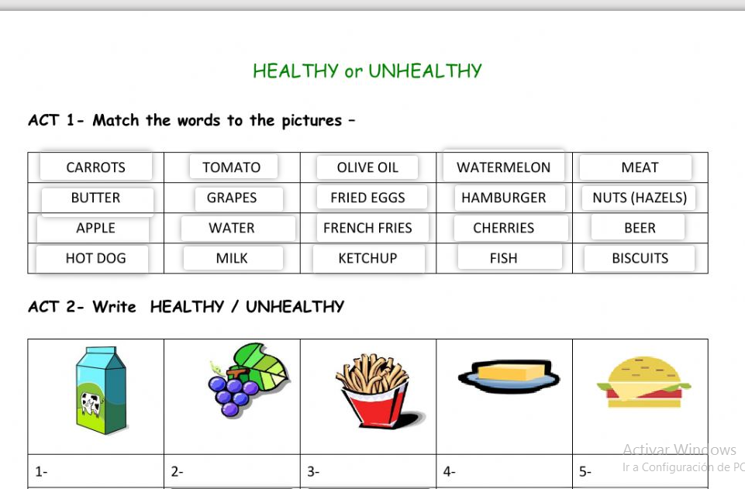

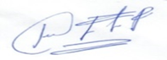

ENGLISH TEACHER:
IMELDA VALDEZ
0979375993

