**ACTIVITIES: WEEK 14**

**NAME:______________________**

**LEVEL:_______________________**

**TOPIC: pronouns infenitives /pronombrtes indefinidos**

Link : <https://es.liveworksheets.com/ti1850616ca>

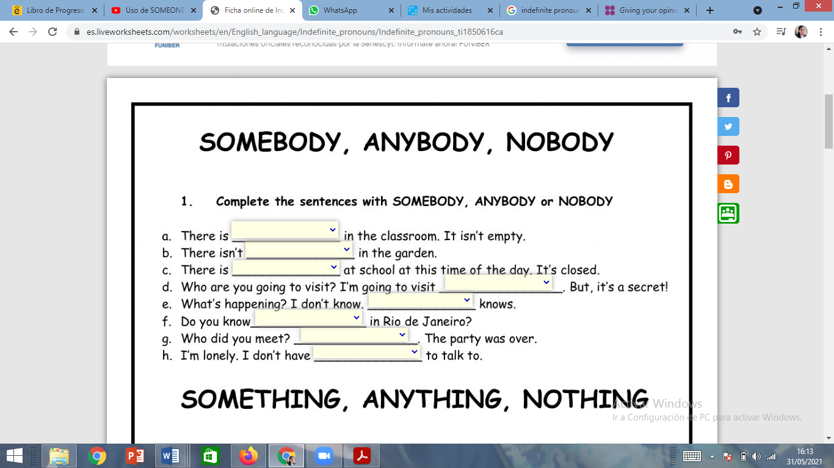

ENGLISH TEACHER:

IMELDA VALDEZ

0979375993