TASK 14 First BGU
NAME:__________
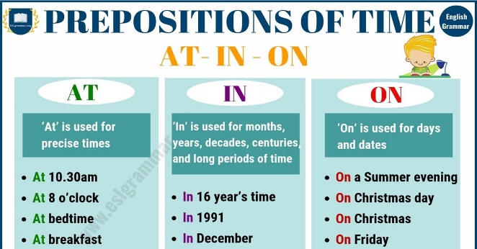
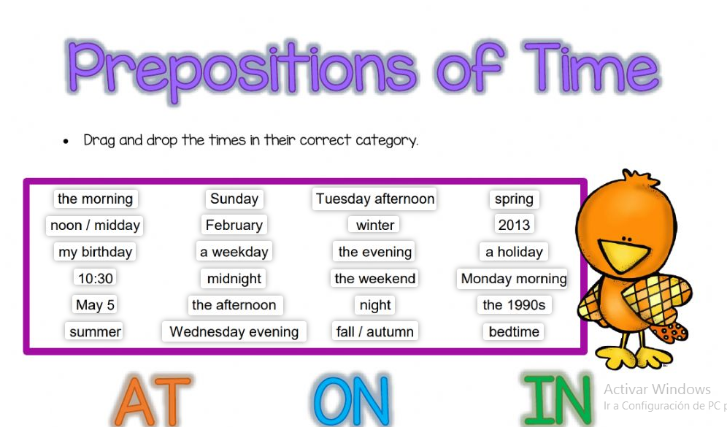
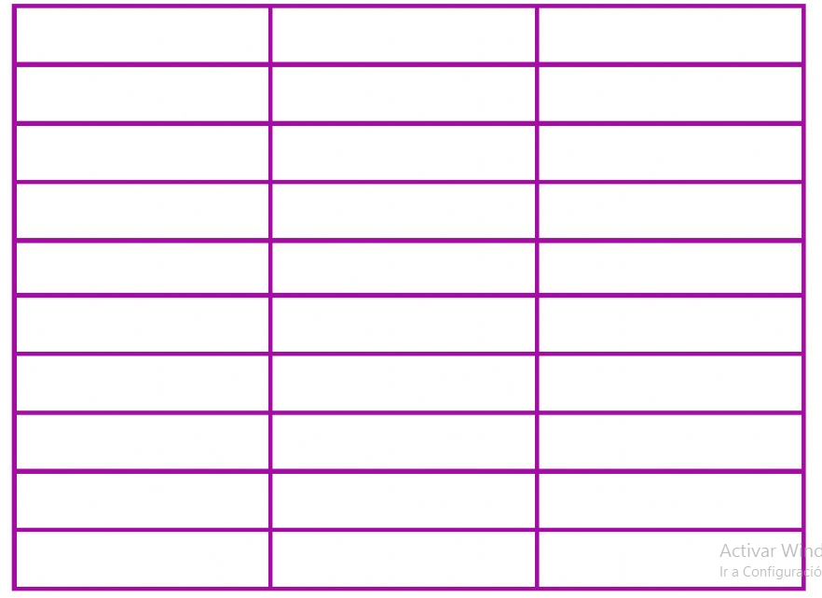
CLAS ACTIVITY: https://es.liveworksheets.com/lg1255882nz

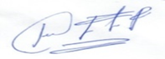
ENGLISH TEACHER:
IMELDA VALDEZ
0979375993

