**TASK 15**

**10TH EGB**

**NAME:__________**

In your notebook, write a description of a place you would like to visit in Ecuador using the tip to the left of the picture. Also, write a slogan such as “All you need is Ecuador.” 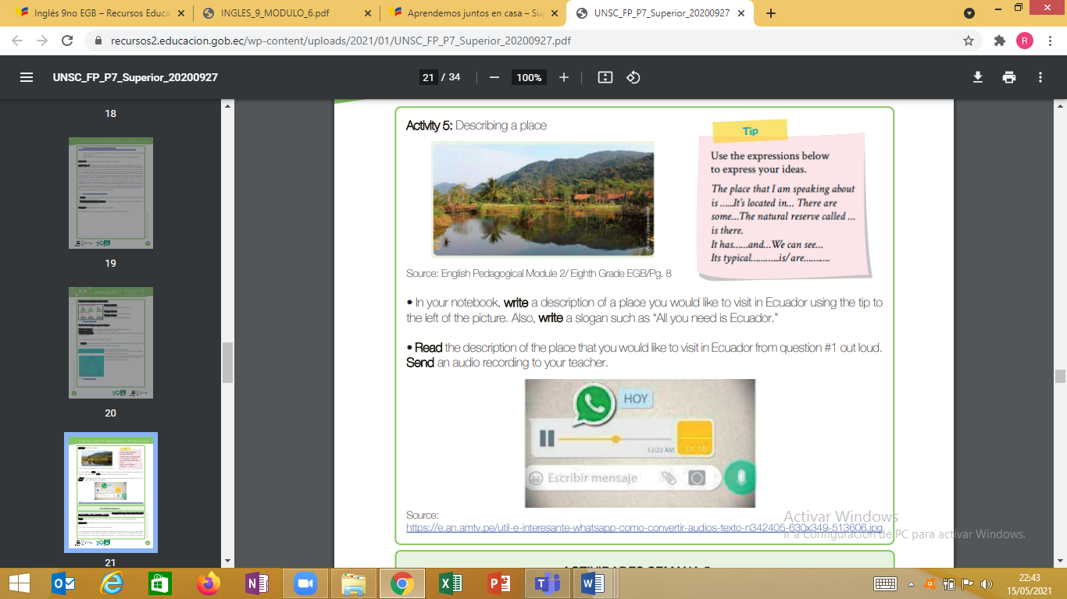

**DESCRIPTION OF PLACE**

**________________________________________________________________________________________________________________________________________________________________________________________________________________________________________________________________________________________________________________________________________________________________________**

CLAS ACTIVITY: <https://es.liveworksheets.com/kg443379xy>



ENGLISH TEACHER:

IMELDA VALDEZ

0979375993