NAME:______________________
LEVEL: ______________________
ACTIVITY: 14
READING
https://es.liveworksheets.com/xn212825yb
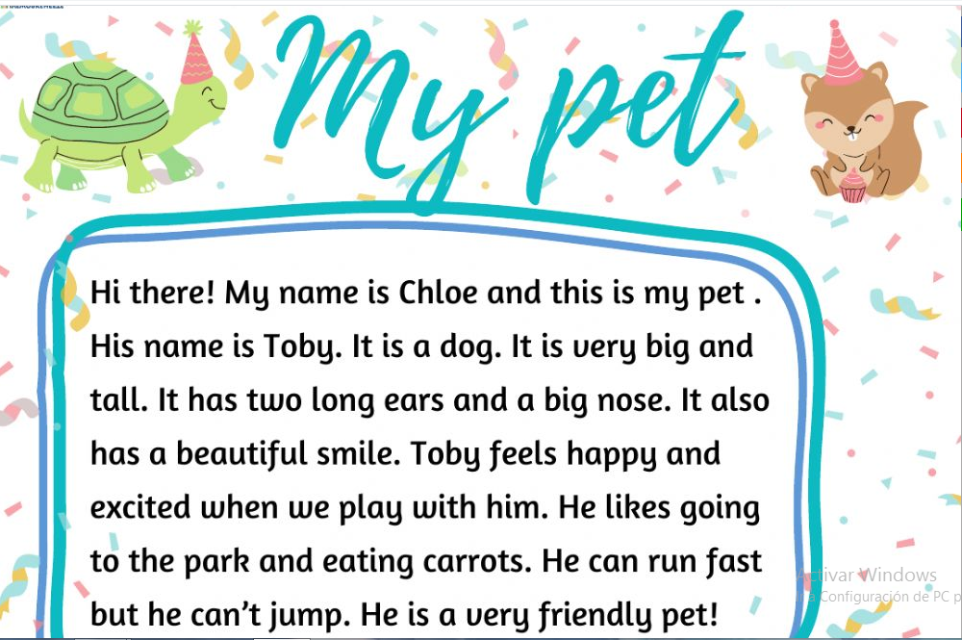
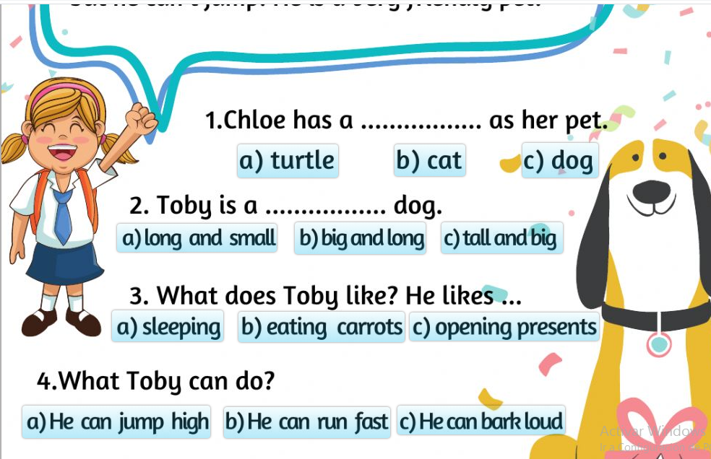
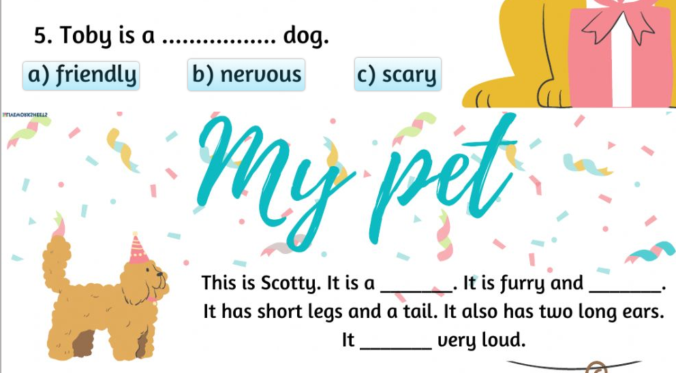
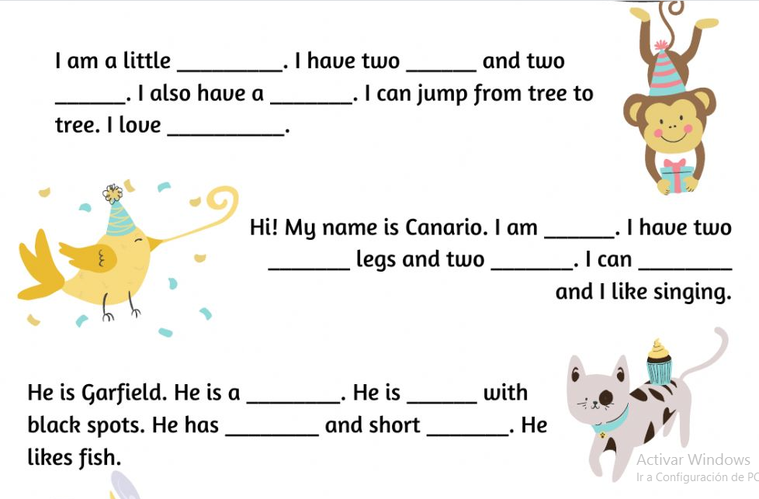

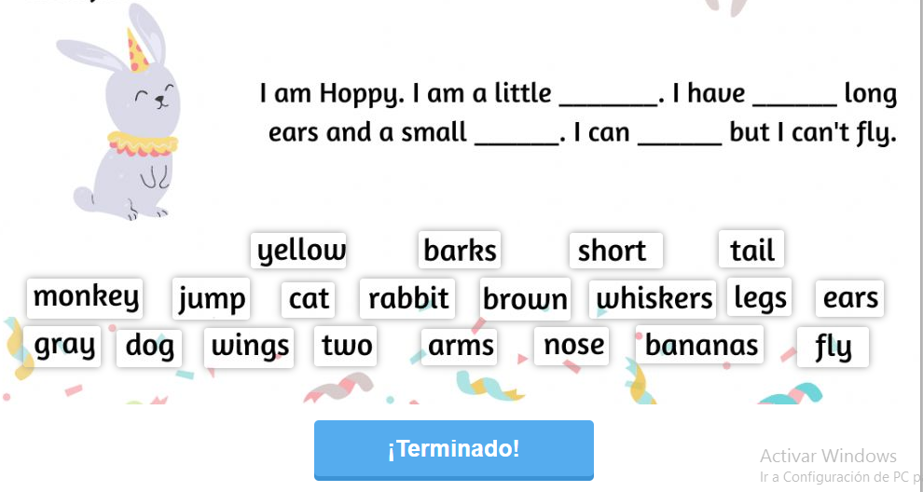

ENGLISH TEACHER:
IMELDA VALDEZ
0979375993

