NAME:______________________
LEVEL: ______________________
QUIZ PROYECT 6
READING
https://es.liveworksheets.com/lv448973sh
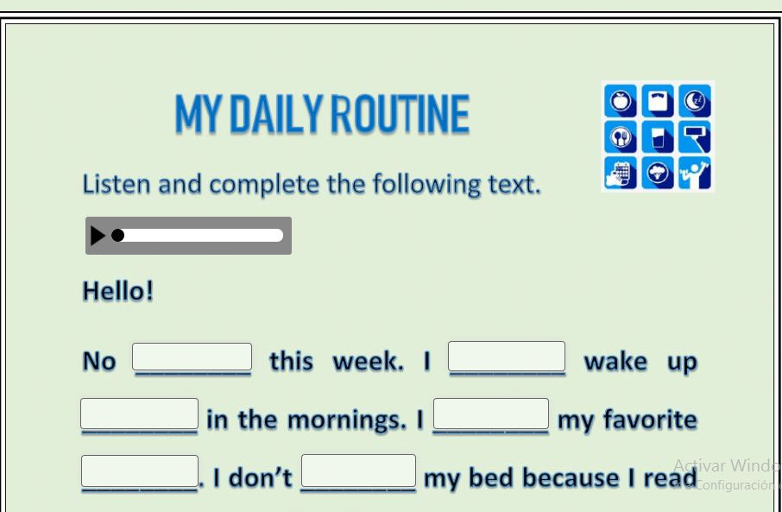
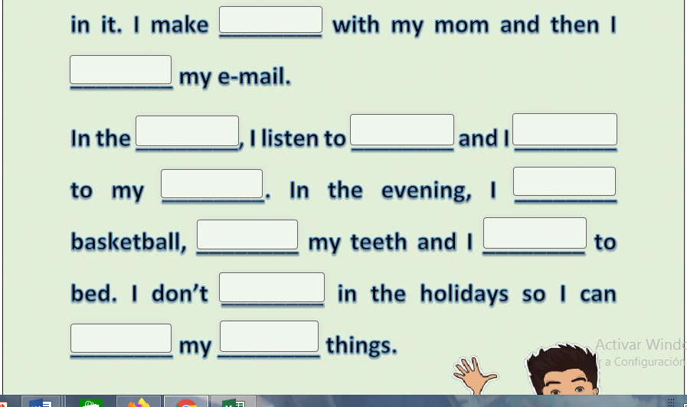

ENGLISH TEACHER:
IMELDA VALDEZ
0979375993

