**TASK 12 SECOND QUIMESTER**

**THIRD BGU**

**NAME_______________________________________________________________________**

READING

What are some natural disasters you know? Who or what do you think causes them?

Natural Disasters in Ecuador

There are different types of natural disasters that occur in Ecuador;one is an earthquake. An earthquake happens when the plates of the earth move against each other. Hundreds of earthquakes have been recorded in Ecuador. The strongest earthquake in the country that has been measured was on December 12, 1979. It happened in the Pacific Ocean on the border between Ecuador and Colombia and measured 8.2 on the Richter scale. It caused a tsunami, which is another type of natural disaster. It is a long high wave that can cause a lot of destruction. Volcanic eruptions are another type of natural disaster. In Ecuador, including the Galapagos Islands, 27 potentially active volcanoes have been counted. Some of the most famous of these are the Cotopaxi, Reventador, Cayambe, and Tungurahua. Volcanoes can be erupting, active, dormant (not active but may be in the future), or extinct (has not erupted in over 10,000 years). The state of Ecuador’s volcanoes has been monitored for decades. Wildfires are also a natural disaster that occur in Ecuador. During the past few years, more and more wildfires have been registered, especially during the summer months of June, July, and August in the highlands. Many acres of land have been burned. When the weather is dry and warm, wildfires are more likely to occur. We have to be careful because with these conditions, fires can spread quickly and destroy a lot of land.

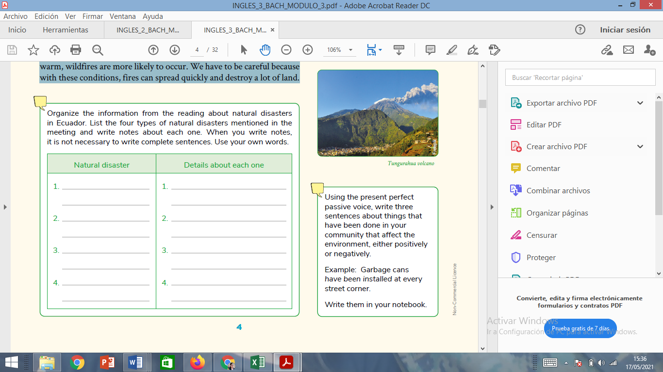

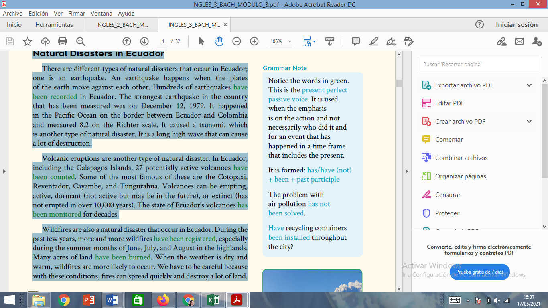

TAREA EN CLASES <https://es.liveworksheets.com/vp698805kf>

