**TASK 12 SECOND QUIMESTER**

**SECOND BGU**

**NAME_______________________________________________________________________**

PASSIVE VOICE

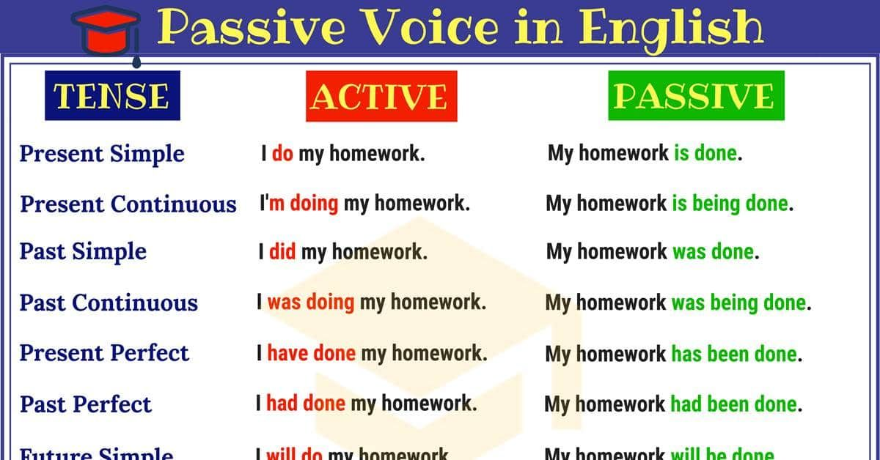

<https://es.liveworksheets.com/cz1348744gd>

