TASK 12 1 BGU
NAME:
TEMA: NOUNS

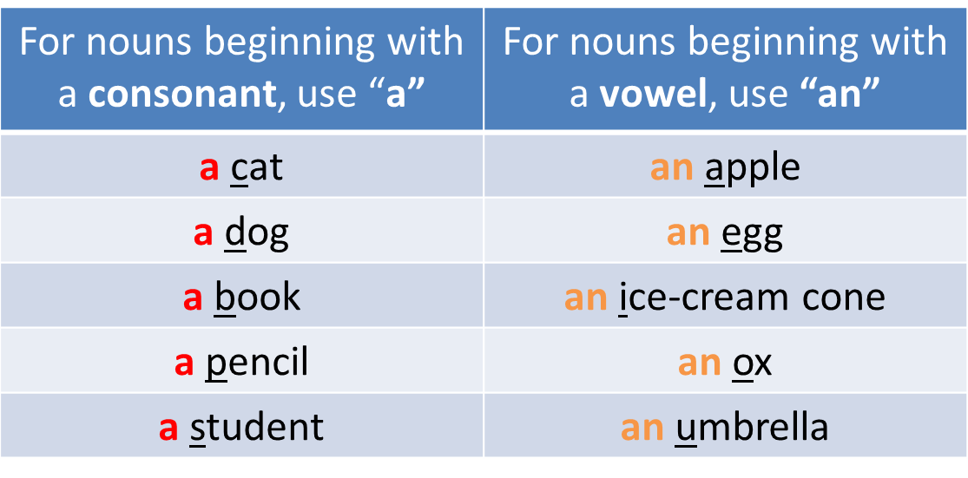
DO THE ACTIVITY AND TAKE THE CAPTURE

https://es.liveworksheets.com/ki1675732jh
