TASK 11 1 BGU
NAME:
TEMA: VOCABULARY

Extreme sports Oral communication Answer this question with your class or with your family. Do you enjoy extreme sports?
___________________________________
Would you like to try some? Why or why not?
_____________________________________
Vocabulary. Match the words with the pictures.
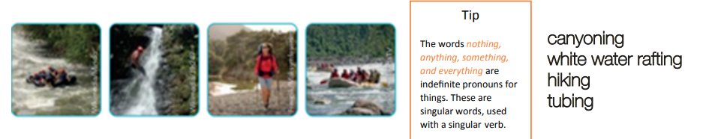
Listening. Listen to a conversation between two friends and answer the questions that follow.
https://www.youtube.com/watch?v=eQg7_6othhM
• Which six activities do the speakers say they are going to do? Mark each one with an X
___canyoning ___snowboarding ___playing soccer ___white water rafting ___hiking ___tubing ___seeing a beautiful parade ___eating delicious food and drinks
• Ambato has a festival where…
a. People enjoy a parade full of floats decorated with balloons.
b. People enjoy throwing water, eggs, and flour at each other.
People enjoy a parade full of floats decorated with fruits and flowers.

