**TASK 10 SECOND QUIMESTER**

**SECOND BGU**

**NAME_______________________________________________________________________**

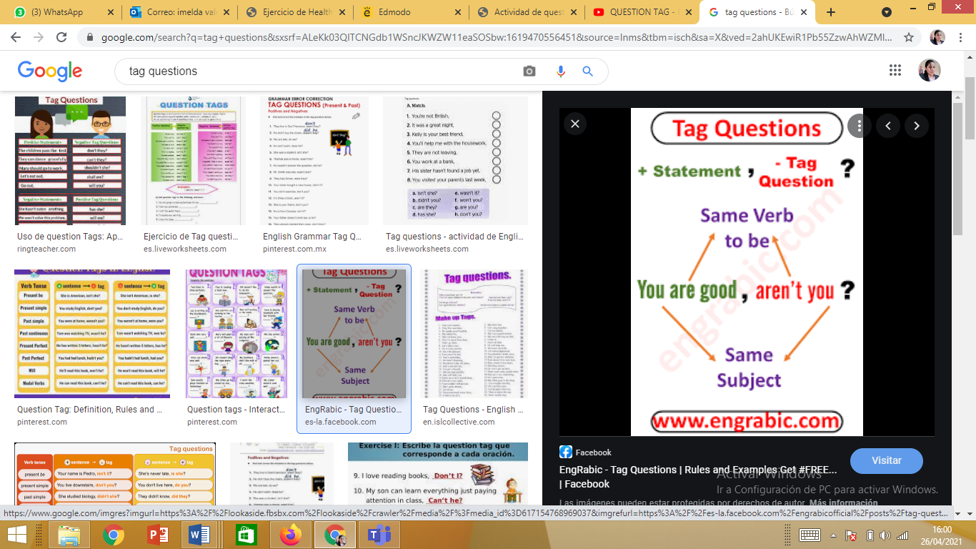

<https://es.liveworksheets.com/nu681763jt>

