**TASK 8 SECOND QUIMESTER**

**THIRD BGU**

**NAME_______________________________________________________________________**

S +VP+C

IF I STUDY ENGLISH,I HAVE A CERFICATE.

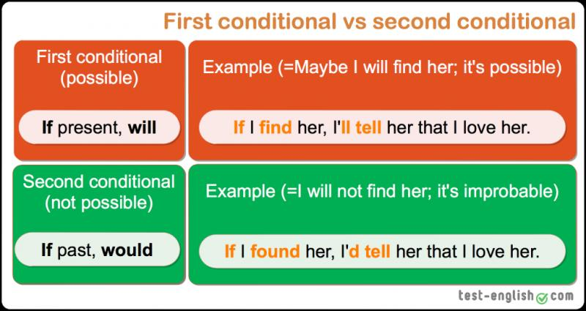

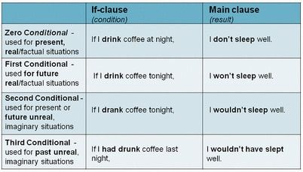

WRITE ONE EXAMPLES OF EACH ONE.

|  |  |  |
| --- | --- | --- |
|  | CONDITIONAL STRUCTURE | EXAMPLES |
| FIRST CONDITIONAL | IF +PRESENT SIMPLE,THEN FUTURE(WILL)SIMPLE | IF I THE WEATHER IS GOOD ,I WILLGO TO THE BEACH |
| SECOND CONDITIONAL | IF+PAST SIMPLE,THEN PAST SIMPLE | IF I DRANK COFFE TONIGHT,I WOULD NOT SLEEP WELL |
| FIRST CONDITIONAL |  |  |
| FIRST CONDITIONAL |  |  |
| SECOND CONDITIONAL |  |  |
| SECOND CONDITIONAL |  |  |

DO THE ACTIVITY AND TAKE CAPTURE

<https://es.liveworksheets.com/gu419117yq>