**TASK 8 SECOND QUIMESTER**

**SECOND BGU**

**NAME_______________________________________________________________________**

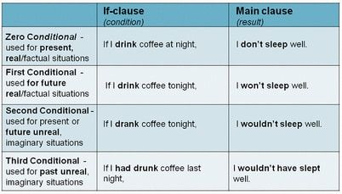

WRITE ONE EXAMPLES OF EACH ONE.

|  |  |  |
| --- | --- | --- |
|  | IF-CLAUSE | MAIN CLAUSE |
| SECOND CONDITIONAL | IF +PAST SIMPLE,THEN MODALS PAST |  |
|  |  |  |
|  |  |  |
|  |  |  |
|  |  |  |
|  |  |  |

WHATCH THE VIDEO AND DO THE ACTIVITY

<https://www.youtube.com/watch?v=c02AEyUEBvA>

DO THE ACTIVITY AND TAKE CAPTURE

<https://es.liveworksheets.com/lj1705573tn>