**TASK 7 SECOND QUIMESTER**

**3 BGU**

**NAME_______________________________________________________________________**

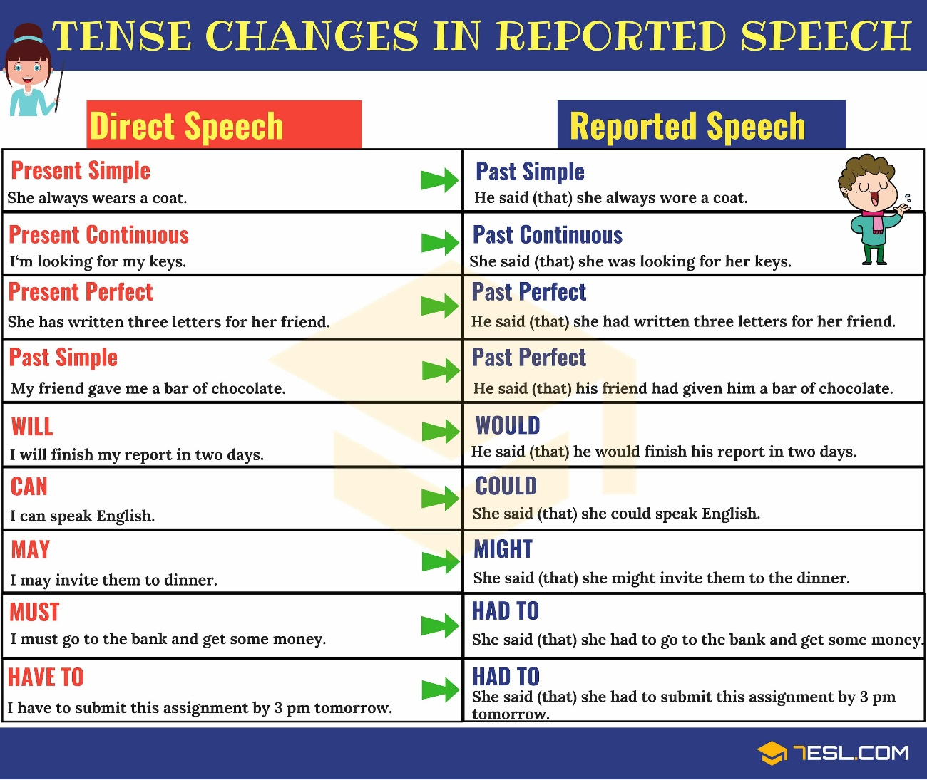_______________________________________________________________________

DO THE TASK AND TAKE A CAPTURE PUT HERE WITH THE GRADE

<https://es.liveworksheets.com/xd1235995fz>

