**TASK 7 SECOND QUIMESTER**

**SECOND BGU**

**NAME_______________________________________________________________________**

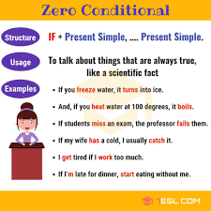

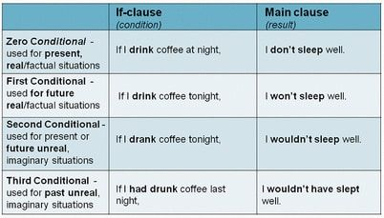

WRITE ONE EXAMPLES OF EACH ONE.

|  |  |  |
| --- | --- | --- |
|  | IF-CLAUSE | MAIN CLAUSE |
| ZERO CONDITIONAL | IF +PRESENT SIMPLE,THEN PRESENT SIMPLE |  |
|  |  |  |
|  |  |  |
|  |  |  |
|  |  |  |
|  |  |  |

DO THE ACTIVITY AND TAKE CAPTURE

<https://es.liveworksheets.com/pj329073gs>