**TASK 7**

**10TH EGB**

NAME:______________________________________________________________________

1. Look at the pictures and circle 4 daily routines that you did

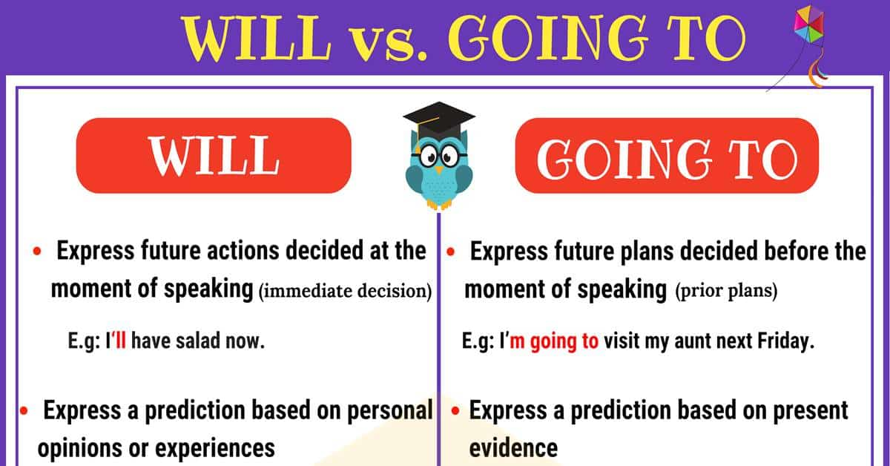

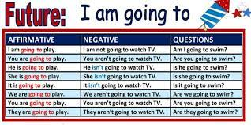

1. write afirmative sentences

1_______________________________________________________

2___________________________________________________________

3.__________________________________________________________

4._____________________________________________________________

Bwrite negative sentences in future

1__________________________________________________________

2___________________________________________________________

3.___________________________________________________________

4________________________________________________________________

Write question sentences in future

1_________________________________________________________

2_______________________________________________________

3_______________________________________________________

4__________________________________________________________