**TASK 6:**

**10TH EGB**

NAME:______________________________________________________________________

1. Look at the pictures and circle 4 daily routines that you did

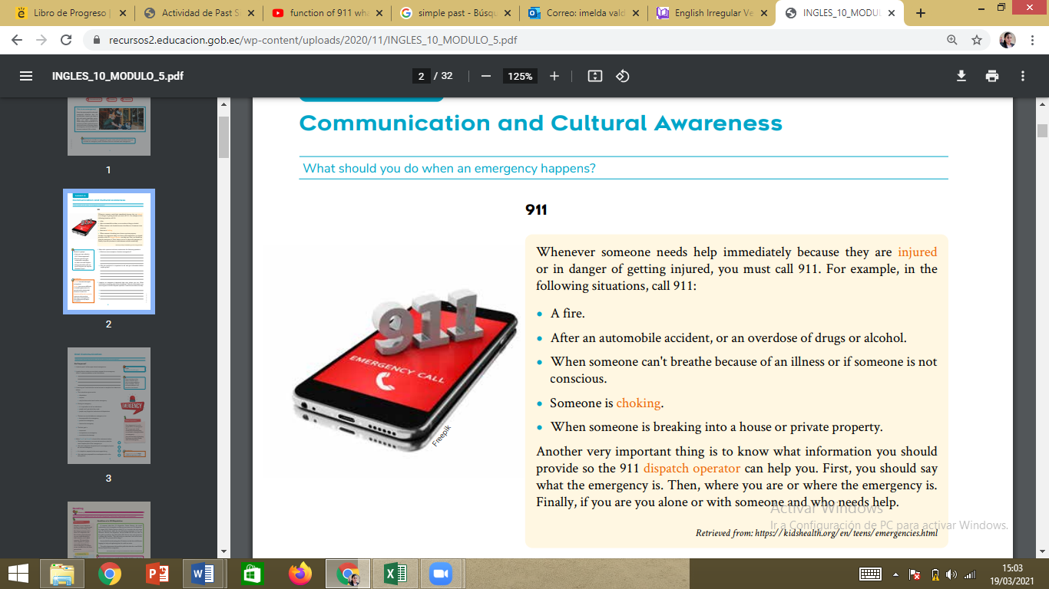

1. Work with a partner to discuss and answer the following questions.

a. What are some examples of serious emergencies? 1_______________________________________________________

2___________________________________________________________

b. Why do you think it is important to call and give information before anything else?

1__________________________________________________________

2___________________________________________________________

Imagine an emergency happened right now where you are. What information would you give to the dispatcher? Write the information you have to give to the 911 dispatch operator. Check the text above for help.

1_________________________________________________________

2_______________________________________________________

3_______________________________________________________