**TASK 5: SIMPLE PAST**

**10TH EGB**

NAME:______________________________________________________________________

1. Look at the pictures and circle 4 daily routines that you did

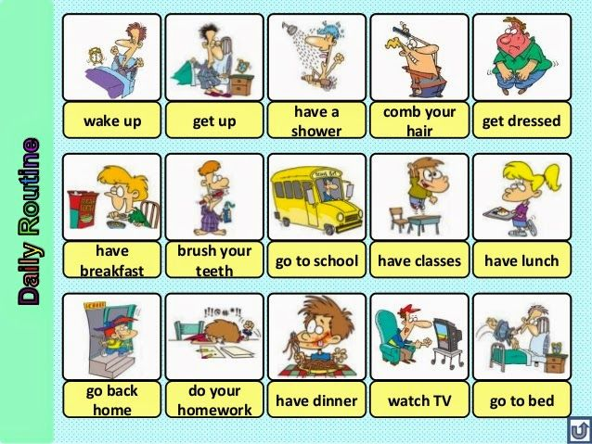

Write afirmative sentences in past simple with the verb that you circule before

1_______________________________________________________

2___________________________________________________________

3__________________________________________________________

4___________________________________________________________

Write the negative sentences in pastt simple

1_________________________________________________________

2_______________________________________________________

3_______________________________________________________

4____________________________________________________________

Write the question sentences in past simple

1____________________________________________________________

2___________________________________________________________

3___________________________________________________________

4________________________________________________________